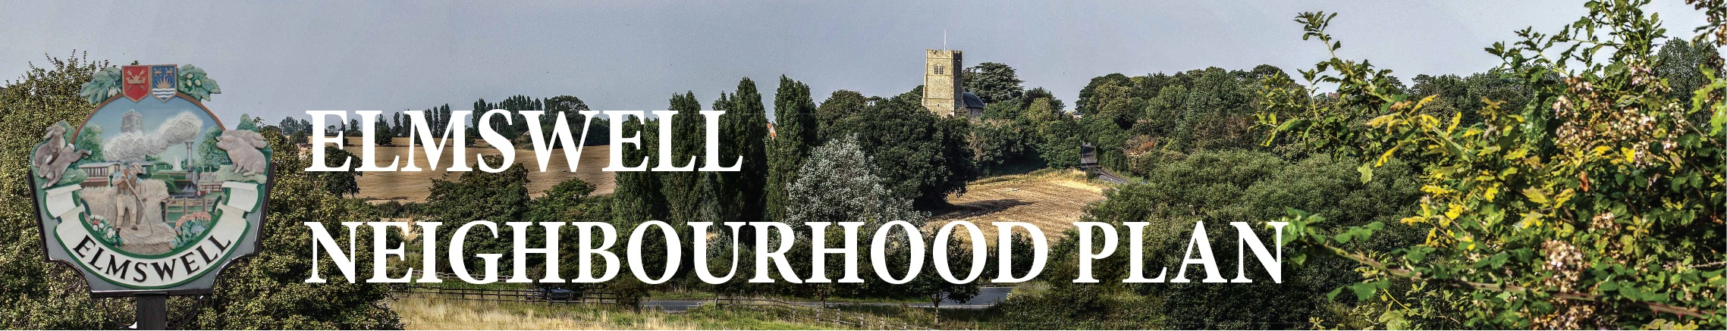

MINUTES OF A STEERING GROUP MEETING
held on Tuesday 18th August 2015
at 7.30pm at The Blackbourne
Present: Peter Dow, Peter Edmonds, Mary Feeney, Terry Garner, Peter Goodridge,
Sarah Mansel (Ch.), Fred Pallett, Shaun Pratt, Lesley Reed, Ann Richards.
Guests: Gillian Benjamin of CAS
Nick Ward of MSDC
Duncan Merren of MSDC
1 Apologies were noted from Marian Abbott, Philip Blissett & Julie Cole.
2 Nick Ward and Duncan Merren were welcomed as newcomers to the Elmswell plan process.
3 The Minutes of the last meeting, held on 23rd July, were approved as a true record.
4 There were no matters arising from the Minutes and not dealt with as an Agenda item.
5 The following feedback was noted towards drafting the Plan document:
5.1 ‘INTRODUCTION’: Julie confirmed that the updated school statistics confirm that the
Bacon Factory development will push Elmswell school beyond its limits and that
capacity will be reached by 2018.
5.1.1 It was generally agreed that the 25 year span of the Plan means that it must
consider site allocations for a school if the school is not to be a constraint on
development and that Julie is to approach the Head teacher and invite liaison.
5.2 ‘VISION & AIMS’: It was agreed that Peter D’s draft can stand as the basis for this
section to be amended as necessary in light of progress in other areas.
5.3 ‘CONTEXT & GENERAL DATA’: The data identified thus far by Peter G & Ann was
reviewed and agreed as extremely sound. The following observations ensued:
5.3.1 There needs to be a conformity of presentation, a ‘house style’. Peter D to
produce a mock-up document bringing the various sections together.
5.3.2 More train information is needed – Sarah & Gillian to pursue, particularly re
freight traffic.
5.3.3 More information re cycle routes is needed – Peter D to let Ann have the
Elmswell / Woolpit Community Path plans, Sarah to produce details of the
adjacent National Cycle Route networks which might be relevant.
6 The following was discussed towards engaging with the remaining sections as suggested by
Dave Chetwyn:
6.1 ‘COMMUNITY ENGAGEMENT’: Gillian, Fred, Mary & Sarah to meet and begin
drafting, Peter D to provide secretariat.
6.2 ‘GROWTH STRATEGY’: Awaiting feedback from other areas; no action determined
but noted that:
6.2.1 Population data & trends needed.
6.2.2 The historic link between housing growth and other infrastructure growth needs to be mapped to inform projections / identify anticipated shortfall.
...over...
6.3 ‘POLICIES’: No action determined – to gradually be shaped as informed by emerging
Growth Strategy.
7 In consultation with Nick & Duncan it seemed unlikely that MSDC representation could be
expected at every NPSG meeting, but regular contact is essential and ad hoc visits will be feasible. Any substantive drafting might be constructively copied to MSDC for feedback.
7.1 It was agreed that Peter D should try to have Andrew MacMillan attend from MSDC to
the next meeting to update the Group on the Call For Sites process as it might inform specific site allocations.
8 Peter D confirmed that he had made contact with AECOM re Direct Technical Support but that
they were yet to come back re whether or not the specific areas of interest - traffic survey/
housing needs survey/ review of Relief Road costing estimates - fall within their remit.
9 When AOB was invited it was noted that the Lavenham Plan has a ‘Projects’ appendix which
lists community projects outside of the purview of the Plan proper but worthy of flagging up
against the possibility of future action by others. This was compared to Elmswell’s
differentiation between ‘Neighbourhood Plan’ and ‘Village Plan’ issues and generally
considered a good idea for incorporation.
10 The date for the next meeting was agreed as Thursday 10th September at 7.30.
10.1 Apologies in advance were noted from Fred and Terry.
11 The meeting closed at 9.00.
Peter Dow
09.09.15

